Create Transfer CIP to FA - Workflow Functional Document

Application: | NGERP-CENTRA
WorkFlow: | FAM (Fixed Asset Management)
WorkFlow Item Name: | Create Transfer CIP to FA

Description:

Fixed Asset Management (FAM) in an ERP system focusing on managing an organization's fixed assets throughout their lifecycle. The Key functions of FAM are Asset tracking & valuation, Depreciation Management and Disposal which includes Sales and Writeoff’ s.

Workflow Process Diagram:

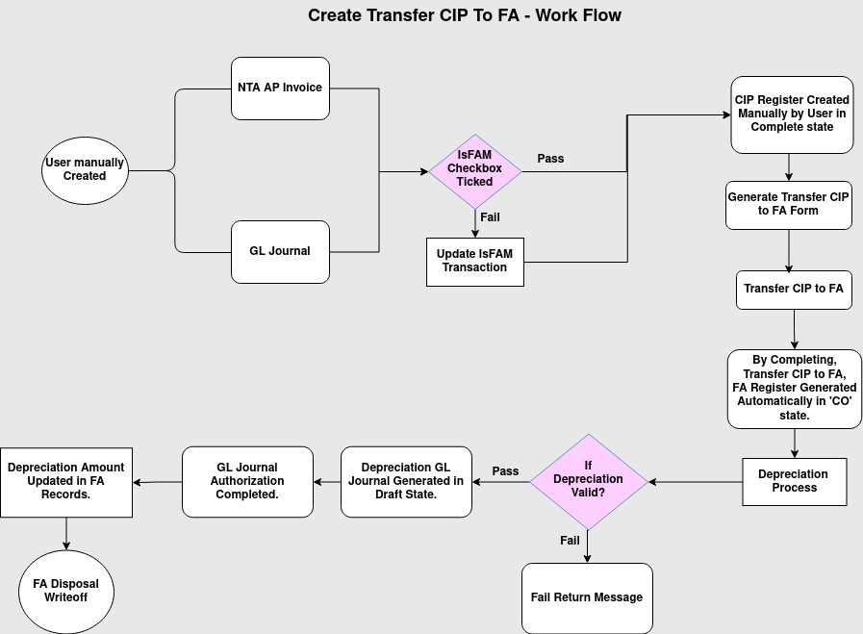

Business Rules:

- User manually created NTA AP Invoice or GL Journal with FAM check Box True.
- NTA AP Invoice allowed to FAM with only NTA product not Charge.
- If FAM checkbox is not true then use update IsFAM Transaction Form move to FAM.
- NTA AP Invoice and GL Journal Records should be completed state.
- Create CIP register record manually by user.
- The following field are mandatory while creating CIP Register Records: RCE No, RCE Date, Project Name and Department Name then IsVAS or IsGAAP.
- After created and saved, Manually completing the CIP Register Transaction.
- Once CIP Register record completed, Based on that records loading in Generate Transfer CIP to FA form process which is used to transfer CIP Register records to Transfer CIP to FA screen in “Drafted” state.
- The following field are mandatory while completing Transfer CIP to FA Records: Useful Life in Month, Asset Tag No and Asset Owner.
- While completing Transfer CIP to FA records, it will automatically creates FA Register records in FA Register screen in “Completed” state.
- Once FA Register records completed, We must have Useful Life Span of Asset for Depreciation calculate. Based on that Depreciation process should be run manually for respective year and month.
- If Depreciation Process receives response as “Process Completed Successfully”, then Depreciation GL Journal records created automatically by system in “Drafted” state.
- GL Journal Authorization used to complete the Journal records by user manually.
- Once GL Journal record gets completed, then depreciation per month field and depreciation amount has been updated automatically in FA Register Records.
- When FA register’s Useful life in month of asset is closed up then User can manually create FA Disposal Write off and complete it.
- It may possibilities to create FA Disposal Write Off before closing of useful life month depending on Asset ‘s damage or loss.

